Practice Questions

- Simplify the following Boolean function F together with the don't-care conditions d; then express the simplified function in minimum SOP and minimum POS.
Implement two –level (i) NAND-NAND (ii) NOR-NOR (iii) AND –NOR (iv) OR – NAND
(a) F(x, y, z) = Σ(O, 1,2,4,5) d(x, y, z) = Σ (3,6,7)
(b) F(A, B, C, D) = Σ (0,6,8, 13, 14) ; d (A, B, C, D) = Σ (2, 4, 10)
(c) F(A, B, C, D) = Σ (I, 3, 5, 7, 9,15) ; d (A, B, C, D) = Σ (4, 6, 12, 13)

- Determine the input conditions needed to cause the output in figure to go to its active state.
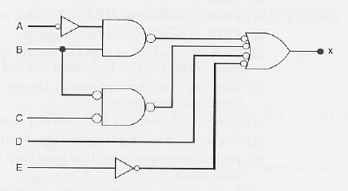

- The circuit figure is supposed to be a simple digital combination lock whose output will generate an active –LOW signal for only one combination of inputs. Modify the circuit diagram so that it represents more effectively the circuit operation. Also modify the circuit for active HIGH. Writdown the statements for both( active HIGH and LOW output).
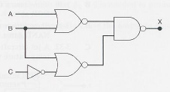
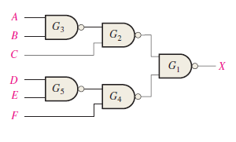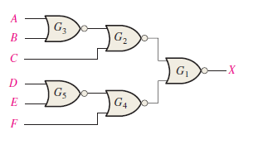
- Simplify the expression for the output of the figure. Also draw the circuits diagram for simplified expression.
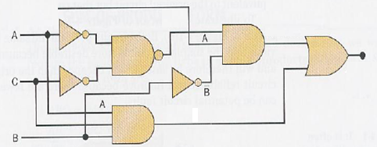

- Write the output expression for each circuit as it appears in Figure and then change each circuit to an equivalent AND-OR configuration.

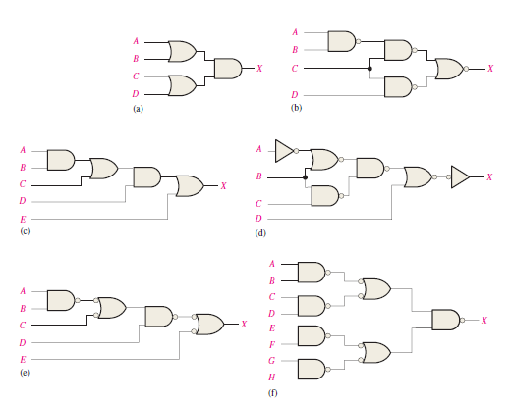

- Simplify the circuit in Figure as much as possible, and verify that the simplified circuit is equivalent to the original by showing that the truth tables are identical.
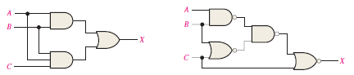

- For the parallel adder in Figure, determine the complete sum by analysis of the logical operation of the circuit. Verify your result by longhand addition of the two input numbers.
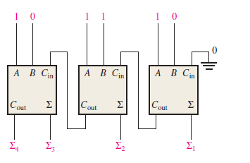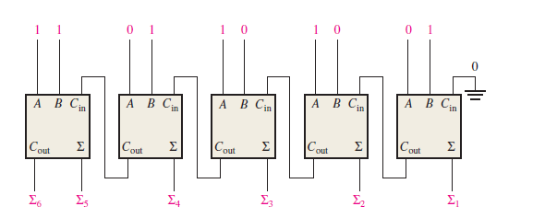

- The circuit shown in Figure is a 4-bit circuit that can add or subtract numbers in a form used in computers (positive numbers in true form; negative numbers in complement form). (a) Explain what happens when the Add/Subt. input is HIGH. (b) What happens when Add/Subt. is LOW? ( c) assume the inputs are Add/Subt. A = 1010, and B = 1101. What is the output?
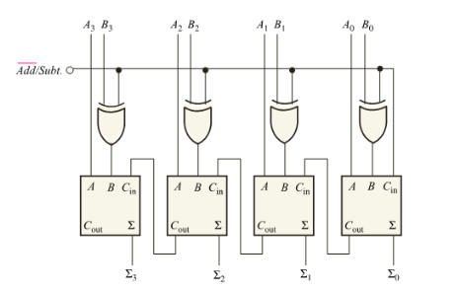
- The input waveforms in Figure are applied to a 2-bit adder. Determine the waveforms for the sum and the output carry in relation to the inputs by constructing a timing diagram.
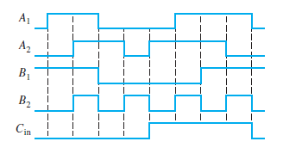

- The waveforms in Figure are applied to the comparator as shown. Determine the output (A = B) waveform.
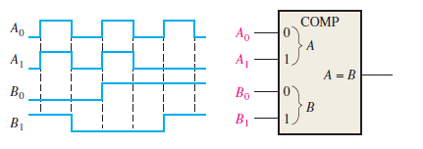
- For the 4-bit comparator in Figure, plot each output waveform for the inputs shown. The outputs are active-HIGH.

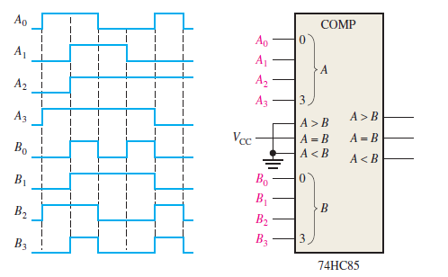

- Show the decoding logic for each of the following codes if an active-HIGH (1) output is required: (a) 1101 (b) 1000 (c) 11011 (d) 11100
- Solve above Problem, given that an active-LOW (0) output is required.
- You wish to detect only the presence of the codes 1010, 1100, 0001, and 1011. An active-HIGH output is required to indicate their presence. Develop the minimum decoding logic with a single output that will indicate when any one of these codes is on the inputs. For any other code, the output must be LOW.

- If the input waveforms are applied to the decoding logic as indicated in Figure 6–76, sketch the output waveform in proper relation to the inputs.
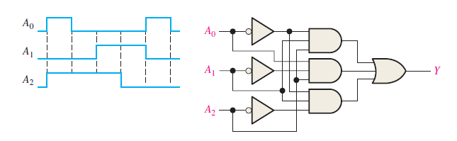
- BCD numbers are applied sequentially to the BCD-to-decimal decoder in Figure 6–77. Draw a timing diagram, showing each output in the proper relationship with the others and with the inputs.
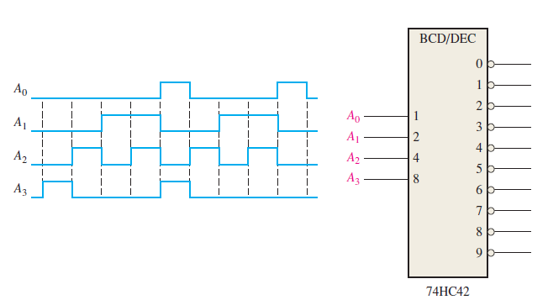
- A 7-segment decoder/driver drives the display in Figure . If the waveforms are applied as indicated, determine the sequence of digits that appears on the display.

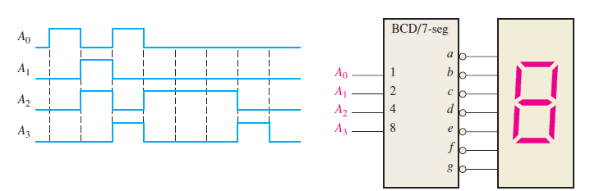

- For the decimal-to-BCD encoder logic of Figure, assume that the 9 input and the 3 input are both HIGH. What is the output code? Is it a valid BCD (8421) code?
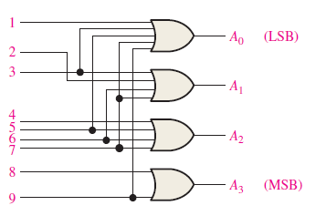
- A 74HC147 encoder has LOW levels on pins 2, 5, and 12. What BCD code appears on the outputs if all the other inputs are HIGH?
- Design a logic circuit whose output is High only when a majority of inputs A, B and C are Low.
- Design a circuit that produced a HIGH out only when all three inputs are at the same level.
- The notataion x1 x0represents a two-bit binary number that can have any value (00, 01, 10,11); for example , when x1= 1, x0 = 0 , the binary number is 10, and so on. Similarly y1, y0 represent another two-bit binary number. Design a logic circuit, using x1,x0,y1, and y0 inputs , whose output will be HIGH only when the two binary numbers x1 x0 and y1 y0 are opposite.
- A four-bit binary number is represented as A3, A2, A1, A0, where A3 , A2, A1 and A0 represent the individual bits and A0 is equal to the LSB. Design a logic circuit that will produce a HIGH out put whenever the binary number is greater than 0010 and less than1000.
- Write the function table for a half subtractor ( input A and B, output DIFF and CARRY). From the function table, design two logic circuits that will act as half subtractor.
- Derive an expression for 2-bit magnitude comparator using Table.
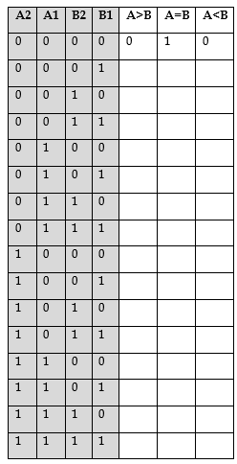
- A BCD-to-seven-segment decoder is a combinational circuit that converts a decimal digit in BCD to an appropriate code for the selection of segments in a display indicator used for displaying the decimal digit in a familiar form. The seven outputs of the decoder (a, b, c, d. e,j, g) select the corresponding segments in the display, as shown in Fig. P4-l6(a). The numeric designation chosen to represent the decimal digit is shown in Fig. P4-16(b). Design the BCD-to-seven-segment decoder using a minimum number of NAND gates. The six invalid combinations should result in a blank display.
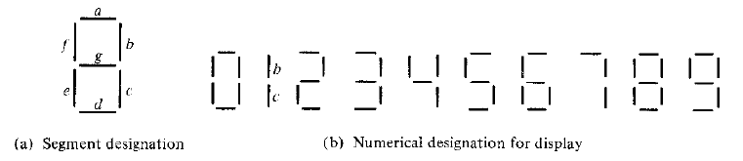

- Show the logic required to convert a 10-bit binary number to Gray code and use that logic to convert the following binary numbers to Gray code:
(a) 1010111100 (b) 1111000011 (c) 1011110011 (d) 1000000001
- Show the logic required to convert a 10-bit Gray code to binary and use that logic to convert the following Gray code words to binary:
(a) 1010111100 (b) 1111000011 (c) 1011110011 (d) 1000000001

- For the multiplexer in Figure1, determine the output for the following input
states: D0 = 1, D1 = 0, D2 = 0, D3 = 1,
- S0 = 0, S1 = 1 (b) S1 = 0, S1 = 1 (c) S0 = 1, S1 = 0
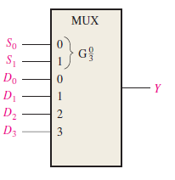 Figure1

- If the data-select inputs to the multiplexer in above Figure1 are sequenced as shown by the waveforms in Figure2, determine the output waveform with the data inputs specified in Problem3.

Figure2 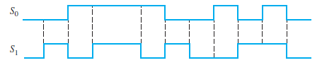

- The waveforms in Figure3 are observed on the inputs of a 74HC151 8-input multiplexer. Sketch the Y output waveform.
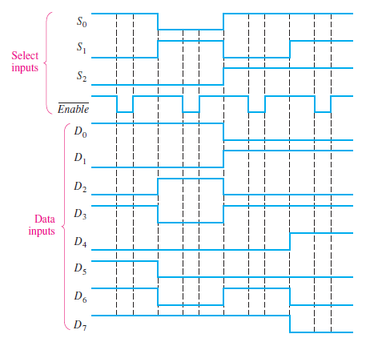
- Develop the total timing diagram (inputs and outputs) for a 74HC154 used in a demultiplexing application in which the inputs are as follows: The data-select inputs are repetitively sequenced through a straight binary count beginning with 0000, and the data input is a serial data stream carrying BCD data representing the decimal number 2468. The least significant digit (8) is first in the sequence, with its LSB first, and it should appear in the first 4-bit positions of the output.
- Implement the following Boolean function using decoder.
(A, B, C,D) = Σ ( 1, 2, 3, 7,9,13,15)
- Implement the logic function in table by using a 74S151 8 input data selector/multiplexer. X(A₃, A₂, A₁, A₀) = ∑(2,3,4,8,9,10,11,15)
- Implement a full adder circuit by using:
(a)3 – to - 8 line Decoder (b) 4 X 1 Multiplexers.
- Construct a 16 X 1 multiplexer using 8x1 and 2x1 multiplexers

